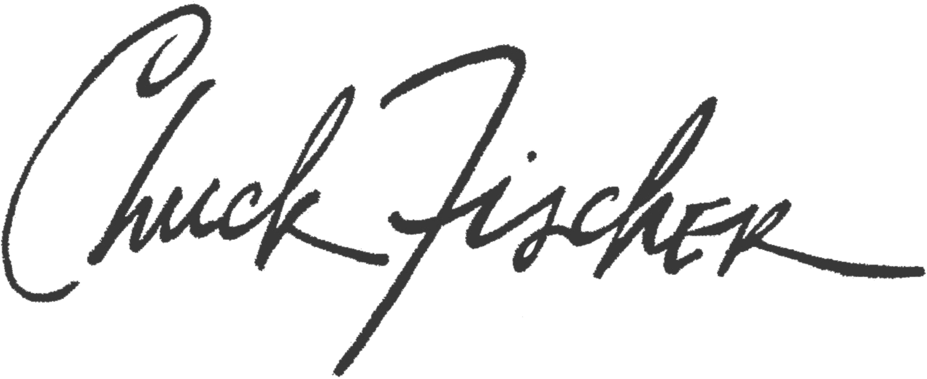

Artist Statement

Textured abstractions encompassing a broad spectrum of color and materials exhibit the multiplicity and goal-oriented motion of my work. Through the repetitive use of independent abstract forms, I spontaneously fuse distinct elements together in an expressive counterpoint. Using a musical term as metaphor, my work is polyphonic, as I simultaneously combine multiple textured parts, each forming an individual statement while harmonizing with each other.

Possessed with a strong belief in the Bauhaus movement to create works of art in which all the arts, including architecture and design, exist on equal footing ‘without class snobbery’. Working in series and using copper and aluminum as the foundation materials for both my mixed media paintings and sculptural assemblages, a reflective conversation takes place with each piece. Using the inherent motion encompassed in geometric shapes I trust, intuition, chance, and the materials at hand to resolve the abstracted elements in to works of truth and harmony.

Education
B.F.A. - University of Kansas
Visiting Artist - American Academy in Rome (2020)
Director’s Guest Artist - Civitella Ranieri, Umbria, Italy
Attingham Trust Scholar - Great Britain (2013)
Art Students League, New York City - Bruce Dorfman (2018, 2019, 2020)

Museum and Gallery Exhibitions

New Directions 2020 – Barret Art Center, Poughkeepsie, NY
New Hope Arts – Sculpture 2020 – New Hope, PA
Butler Institute of American Art - 83rd National Midyear Exhibition (2019)
Evansville Museum of Art – By The Light of the Silvery Moon (2019)
Site: Brooklyn - Geometrics – ( 2019)
Gertrude Herbert Institute of Art - 39th Juried Exhibition (2019)
Isabella Garrucho Fine Art - 2019 Summer Group Show (2019)
Keep Contemporary - Santa Fe - 3rd Annual Abstract Art Invitational (2019)
Keep Contemporary - Santa Fe - High Art, Low Art Exhibition (2018)
New Hope Arts - Sculpture 2019 – New Hope, PA
Phyllis Harriman Gallery - New York City - (2019-2020)

Biography

Prior to 2016, when Chuck exclusively committed to his fine art practice, his 9th pop-up book was published. His published works include the bestsellers, Christmas in New York, In The Beginning: The Art of Genesis, and Great American Houses and Gardens. His designs are in the permanent collection of the Cooper Hewitt – Smithsonian National Design Museum, Museum of American History, Washington, D.C., and the Artist Book section at the The Library of Congress.

www.chuckfischerstudio.com

